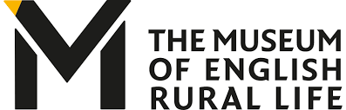
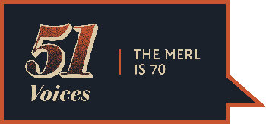

Writing Submission

Thank you for taking part in The MERL Mysterious Voices, part of our 51 Voices project. We invite schools to choose their best entries to share them with us by Friday 26th March. Entries will then be collated and will form one of the voices for each of the objects and displayed as part of our 51 Voices project.

Please submit your entries via email to The MERL Learning Team at merlevents@reading.ac.uk.

School name
School Address
School phone number
School contact name
School contact email

Year groups involved
Total number of pupils involved
Number of submissions
Details of any supporting materials submitted, e.g. photographs (optional)
Details about your pupils, e.g. SEND and EAL, which may be useful for us to know.
How did you use the resources in your teaching?
Which objects did you find the most inspiring?

Would you like to be added to our schools mailing list using the name and email given above? | Yes/No
Do you agree that the writings and supporting materials submitted can be used in whole or in part for The MERL's 51 Voices project and shared onsite at the museum and virtually by The MERL and the University of Reading? | Yes/No
